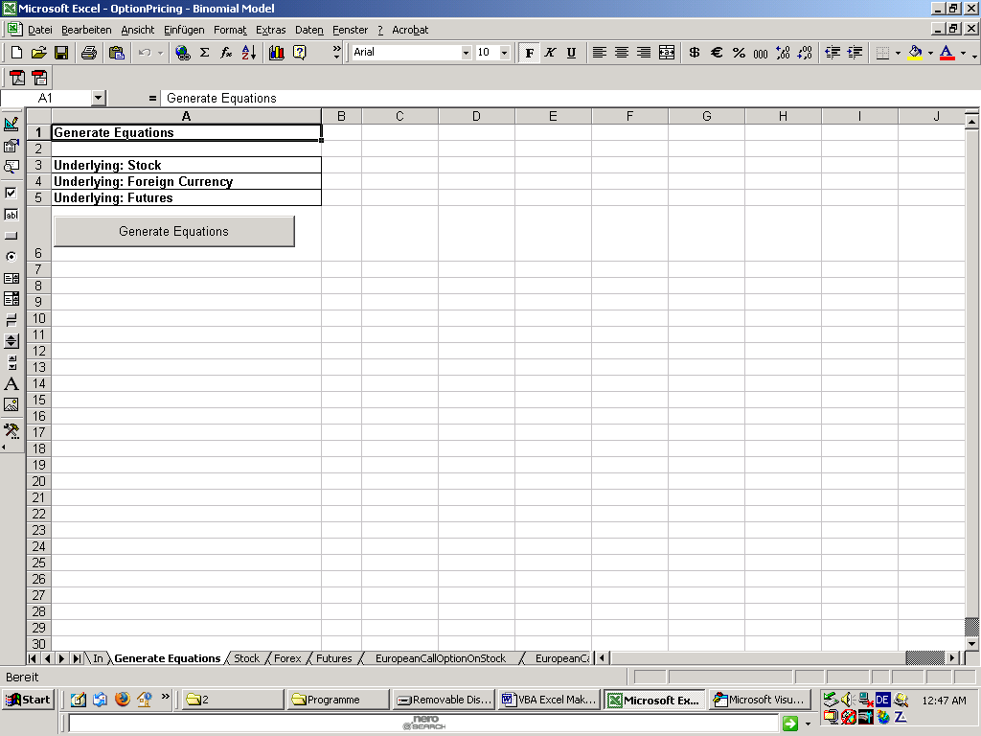

Private Sub CommandButton1_Click()
UserForm1.Left = 430
UserForm1.Top = 300
UserForm1.TextBox1.SelStart = 0
UserForm1.TextBox1.SelLength = UserForm1.TextBox1.TextLength
UserForm1.TextBox2.SelStart = 0
UserForm1.TextBox2.SelLength = UserForm1.TextBox1.TextLength
UserForm1.TextBox3.SelStart = 0
UserForm1.TextBox3.SelLength = UserForm1.TextBox1.TextLength
UserForm1.TextBox4.SelStart = 0
UserForm1.TextBox4.SelLength = UserForm1.TextBox1.TextLength
UserForm1.TextBox5.SelStart = 0
UserForm1.TextBox5.SelLength = UserForm1.TextBox1.TextLength
UserForm1.TextBox6.SelStart = 0
UserForm1.TextBox6.SelLength = UserForm1.TextBox1.TextLength
UserForm1.TextBox7.SelStart = 0
UserForm1.TextBox7.SelLength = UserForm1.TextBox1.TextLength
UserForm1.TextBox8.SelStart = 0
UserForm1.TextBox8.SelLength = UserForm1.TextBox1.TextLength
UserForm1.TextBox9.SelStart = 0
UserForm1.TextBox9.SelLength = UserForm1.TextBox1.TextLength
UserForm1.TextBox10.SelStart = 0
UserForm1.TextBox10.SelLength = UserForm1.TextBox1.TextLength
UserForm1.TextBox11.SelStart = 0
UserForm1.TextBox11.SelLength = UserForm1.TextBox1.TextLength
myInput = Application.InputBox("1-Stock, 2-Forex, 3-Futures", , "1", , , , , 2)
If myInput = "1" Then
UserForm1.TextBox1.Text = "In!$B$6"
UserForm1.TextBox2.Text = "In!$B$5"
UserForm1.TextBox3.Text = "In!$B$8"
UserForm1.TextBox4.Text = "In!$B$9"
UserForm1.TextBox5.Text = "In!$B$15"
UserForm1.TextBox6.Text = "In!$E$5"
UserForm1.TextBox7.Text = "In!$E$6"
UserForm1.TextBox8.Text = "In!$E$7"
UserForm1.TextBox9.Text = "In!$E$8"
UserForm1.TextBox10.Text = "In!$E$9"
UserForm1.TextBox11.Text = "In!$E$10"
ElseIf myInput = "2" Then
UserForm1.TextBox1.Text = "In!$B$21"
UserForm1.TextBox2.Text = "In!$B$20"
UserForm1.TextBox3.Text = "In!$B$22"
UserForm1.TextBox4.Text = "In!$B$26"
UserForm1.TextBox5.Text = "In!$B$28"
UserForm1.TextBox6.Text = "In!$E$20"
UserForm1.TextBox7.Text = "In!$E$21"
UserForm1.TextBox8.Text = "In!$E$22"
UserForm1.TextBox9.Text = "In!$E$23"
UserForm1.TextBox10.Text = "In!$E$24"
UserForm1.TextBox11.Text = "In!$E$25"
ElseIf myInput = "3" Then
UserForm1.TextBox1.Text = "In!$B$36"
UserForm1.TextBox2.Text = "In!$B$35"
UserForm1.TextBox3.Text = "In!$B$37"
UserForm1.TextBox4.Text = "In!$B$39"
UserForm1.TextBox5.Text = "In!$B$40"
UserForm1.TextBox6.Text = "In!$E$35"
UserForm1.TextBox7.Text = "In!$E$36"
UserForm1.TextBox8.Text = "In!$E$37"
UserForm1.TextBox9.Text = "In!$E$38"
UserForm1.TextBox10.Text = "In!$E$39"
UserForm1.TextBox11.Text = "In!$E$40"
End If
Worksheets("In").Activate
UserForm1.Show

End Sub

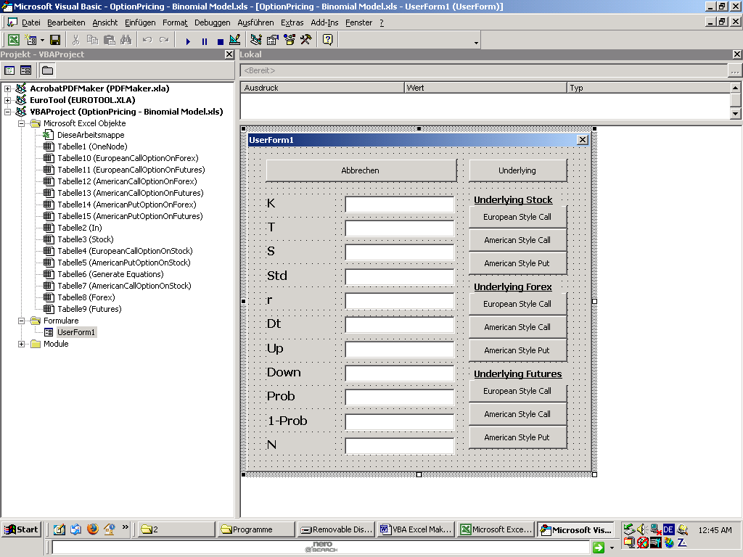

Private Sub CommandButton2_Click()
'UserForm1>Abbrechen
UserForm1.Hide

End Sub

Private Sub CommandButton1_Click()
'UserForm1>Stock:EuropeanStyleCall
UserForm1.Hide
Call GenerateEquationsEuropeanStyleCall("Stock", "EuropeanCallOptionOnStock")

End Sub

Private Sub CommandButton6_Click()
'UserForm1>Forex:EuropeanStyleCall
UserForm1.Hide
Call GenerateEquationsEuropeanStyleCall("Forex", "EuropeanCallOptionOnForex")

End Sub

Private Sub CommandButton9_Click()
'UserForm1>Futures:EuropeanStyleCall
UserForm1.Hide
Call GenerateEquationsEuropeanStyleCall("Futures", "EuropeanCallOptionOnFutures")

End Sub

Function GenerateEquationsEuropeanStyleCall(Underlying As String, OptionType As String)
K = UserForm1.TextBox1.Value
T = UserForm1.TextBox2.Value
S0 = UserForm1.TextBox3.Value
Std = UserForm1.TextBox4.Value
r = UserForm1.TextBox5.Value
Dt = UserForm1.TextBox6.Value
Up = UserForm1.TextBox7.Value
Down = UserForm1.TextBox8.Value
Prob = UserForm1.TextBox9.Value
EinsMinusProb = UserForm1.TextBox10.Value
n = UserForm1.TextBox11.Value
IterMax = Worksheets("In").Range(n).Value
'Clear all
myInput1 = Application.InputBox("Generate New Stock/Forex/Futures Values as well?", , "N", , , , , 2)
If myInput1 = "N" Then
Else
With Worksheets(Underlying)
.Range(.Cells(3, 1), .Cells(257, 254)).ClearContents
End With
End If
With Worksheets(OptionType)
.Range(.Cells(3, 1), .Cells(257, 254)).ClearContents
End With
'Definitionen
mal = "*"
Gleich = "="
Hoch = "^"
minus = "-"
plus = "+"
'Programm für Stock
If myInput1 = "N" Then
Else
For IterUnten = 0 To IterMax
Worksheets(Underlying).Cells(3 + IterUnten, 1).Value = IterUnten
For IterRechts = 0 To IterUnten
'Formel
UpStr = CStr(IterUnten - IterRechts)
DownStr = CStr(IterRechts)
Formel1 = Gleich & S0 & mal
Formel2 = Up & Hoch & UpStr & mal
Formel3 = Down & Hoch & DownStr
Worksheets(Underlying).Cells(3 + IterUnten, 2 + IterRechts).Value = Formel1 & Formel2 & Formel3
Next IterRechts
Next IterUnten
End If
'Programm für Call Option
'Formel für cT
For IterRechts = 0 To IterMax
Formel4 = "R" & CStr(3 + IterMax) & "C" & CStr(2 + IterRechts)
Formel5 = Application.ConvertFormula(Formula:=Formel4, fromReferenceStyle:=xlR1C1, toReferenceStyle:=xlA1)
ST = Underlying & "!" & Formel5
Formel6 = Gleich & "Max(" & ST & minus & K & ",0)"
Worksheets(OptionType).Cells(3 + IterMax, 2 + IterRechts).Value = Formel6
Next IterRechts
'Formel für ct European Style
For IterRunter = 0 To IterMax - 1
IterRauf = IterMax - IterRunter
Worksheets(OptionType).Cells(3 + IterRauf, 1).Value = IterRauf
For IterRechts = 0 To IterRauf - 1
Formel7 = "R" & CStr(3 + IterRauf) & "C" & CStr(2 + IterRechts)
ctj = Application.ConvertFormula(Formula:=Formel7, fromReferenceStyle:=xlR1C1, toReferenceStyle:=xlA1)
Formel8 = "R" & CStr(3 + IterRauf) & "C" & CStr(2 + IterRechts + 1)
ctjplus1 = Application.ConvertFormula(Formula:=Formel8, fromReferenceStyle:=xlR1C1, toReferenceStyle:=xlA1)
Formel9 = Gleich & "exp(" & minus & r & mal & Dt & ")"
Formel10 = mal & "(" & Prob & mal & ctj & plus
Formel11 = EinsMinusProb & mal & ctjplus1 & ")"
Formel12 = Formel9 & Formel10 & Formel11
Worksheets(OptionType).Cells(3 + IterRauf - 1, 2 + IterRechts).Value = Formel12
Next IterRechts
Next IterRunter
Worksheets(OptionType).Cells(3, 1).Value = 0

End Function

Private Sub CommandButton3_Click()
'UserForm1>Stock:AmericanStyleCall
UserForm1.Hide
Call GenerateEquationsAmericanStyleCall("Stock", "AmericanCallOptionOnStock")

End Sub
Private Sub CommandButton7_Click()
'UserForm1>Forex:AmericanStyleCall
UserForm1.Hide
Call GenerateEquationsAmericanStyleCall("Forex", "AmericanCallOptionOnForex")

End Sub
Private Sub CommandButton10_Click()
'UserForm1>Futures:AmericanStyleCall
UserForm1.Hide
Call GenerateEquationsAmericanStyleCall("Futures", "AmericanCallOptionOnFutures")

End Sub

Function GenerateEquationsAmericanStyleCall(Underlying As String, OptionType As String)
K = UserForm1.TextBox1.Value
T = UserForm1.TextBox2.Value
S0 = UserForm1.TextBox3.Value
Std = UserForm1.TextBox4.Value
r = UserForm1.TextBox5.Value
Dt = UserForm1.TextBox6.Value
Up = UserForm1.TextBox7.Value
Down = UserForm1.TextBox8.Value
Prob = UserForm1.TextBox9.Value
EinsMinusProb = UserForm1.TextBox10.Value
n = UserForm1.TextBox11.Value
IterMax = Worksheets("In").Range(n).Value
'Clear all
myInput1 = Application.InputBox("Generate New Stock/Forex/Futures Values as well?", , "N", , , , , 2)
If myInput1 = "N" Then
Else
With Worksheets(Underlying)
.Range(.Cells(3, 1), .Cells(257, 254)).ClearContents
End With
End If
With Worksheets(OptionType)
.Range(.Cells(3, 1), .Cells(257, 254)).ClearContents
End With
'Definitionen
mal = "*"
Gleich = "="
Hoch = "^"
minus = "-"
plus = "+"
'Programm für Stock
If myInput1 = "N" Then
Else
For IterUnten = 0 To IterMax
Worksheets(Underlying).Cells(3 + IterUnten, 1).Value = IterUnten
For IterRechts = 0 To IterUnten
'Formel
UpStr = CStr(IterUnten - IterRechts)
DownStr = CStr(IterRechts)
Formel1 = Gleich & S0 & mal
Formel2 = Up & Hoch & UpStr & mal
Formel3 = Down & Hoch & DownStr
Worksheets(Underlying).Cells(3 + IterUnten, 2 + IterRechts).Value = Formel1 & Formel2 & Formel3
Next IterRechts
Next IterUnten
End If
'Programm für Call Option
'Formel für cT
For IterRechts = 0 To IterMax
Formel4 = "R" & CStr(3 + IterMax) & "C" & CStr(2 + IterRechts)
Formel5 = Application.ConvertFormula(Formula:=Formel4, fromReferenceStyle:=xlR1C1, toReferenceStyle:=xlA1)
ST = Underlying & "!" & Formel5
Formel6 = Gleich & "Max(" & ST & minus & K & ",0)"
Worksheets(OptionType).Cells(3 + IterMax, 2 + IterRechts).Value = Formel6
Next IterRechts
'Formel für ct American Style
For IterRunter = 0 To IterMax - 1
IterRauf = IterMax - IterRunter
Worksheets(OptionType).Cells(3 + IterRauf, 1).Value = IterRauf
For IterRechts = 0 To IterRauf - 1
Formel7 = "R" & CStr(3 + IterRauf) & "C" & CStr(2 + IterRechts)
ctj = Application.ConvertFormula(Formula:=Formel7, fromReferenceStyle:=xlR1C1, toReferenceStyle:=xlA1)
Formel8 = "R" & CStr(3 + IterRauf) & "C" & CStr(2 + IterRechts + 1)
ctjplus1 = Application.ConvertFormula(Formula:=Formel8, fromReferenceStyle:=xlR1C1, toReferenceStyle:=xlA1)
Formel9 = "exp(" & minus & r & mal & Dt & ")"
Formel10 = mal & "(" & Prob & mal & ctj & plus
Formel11 = EinsMinusProb & mal & ctjplus1 & ")"
Formel12 = Formel9 & Formel10 & Formel11
Formel13 = "R" & CStr(3 + IterRauf - 1) & "C" & CStr(2 + IterRechts)
STminus1j = Application.ConvertFormula(Formula:=Formel13, fromReferenceStyle:=xlR1C1, toReferenceStyle:=xlA1)
Formel14 = Gleich & "Max(" & Underlying & "!" & STminus1j & minus & K
Formel15 = "," & Formel12 & ")"
Formel16 = Formel14 & Formel15
Worksheets(OptionType).Cells(3 + IterRauf - 1, 2 + IterRechts).Value = Formel16
Next IterRechts
Next IterRunter
Worksheets(OptionType).Cells(3, 1).Value = 0

End Function

Private Sub CommandButton4_Click()
'UserForm1>Stock:AmericanStylePut
UserForm1.Hide
Call GenerateEquationsAmericanStylePut("Stock", "AmericanPutOptionOnStock")

End Sub

Private Sub CommandButton8_Click()
'UserForm1>Forex:AmericanStylePut
UserForm1.Hide
Call GenerateEquationsAmericanStylePut("Forex", "AmericanPutOptionOnForex")

End Sub

Private Sub CommandButton11_Click()
'UserForm1>Futures:AmericanStylePut
UserForm1.Hide
Call GenerateEquationsAmericanStylePut("Futures", "AmericanPutOptionOnFutures")

End Sub

Sub GenerateEquationsAmericanStylePut(Underlying As String, OptionType As String)
K = UserForm1.TextBox1.Value
T = UserForm1.TextBox2.Value
S0 = UserForm1.TextBox3.Value
Std = UserForm1.TextBox4.Value
r = UserForm1.TextBox5.Value
Dt = UserForm1.TextBox6.Value
Up = UserForm1.TextBox7.Value
Down = UserForm1.TextBox8.Value
Prob = UserForm1.TextBox9.Value
EinsMinusProb = UserForm1.TextBox10.Value
n = UserForm1.TextBox11.Value
IterMax = Worksheets("In").Range(n).Value
'Clear all
myInput1 = Application.InputBox("Generate New Stock/Forex/Futures Values as well?", , "N", , , , , 2)
If myInput1 = "N" Then
Else
With Worksheets(Underlying)
.Range(.Cells(3, 1), .Cells(257, 254)).ClearContents
End With
End If
With Worksheets(OptionType)
.Range(.Cells(3, 1), .Cells(257, 254)).ClearContents
End With
'Definitionen
mal = "*"
Gleich = "="
Hoch = "^"
minus = "-"
plus = "+"
'Programm für Stock
If myInput1 = "N" Then
Else
For IterUnten = 0 To IterMax
Worksheets(Underlying).Cells(3 + IterUnten, 1).Value = IterUnten
For IterRechts = 0 To IterUnten
'Formel
UpStr = CStr(IterUnten - IterRechts)
DownStr = CStr(IterRechts)
Formel1 = Gleich & S0 & mal
Formel2 = Up & Hoch & UpStr & mal
Formel3 = Down & Hoch & DownStr
Worksheets(Underlying).Cells(3 + IterUnten, 2 + IterRechts).Value = Formel1 & Formel2 & Formel3
Next IterRechts
Next IterUnten
End If
'Programm für Put Option
'Formel für pT
For IterRechts = 0 To IterMax
Formel4 = "R" & CStr(3 + IterMax) & "C" & CStr(2 + IterRechts)
Formel5 = Application.ConvertFormula(Formula:=Formel4, fromReferenceStyle:=xlR1C1, toReferenceStyle:=xlA1)
ST = Underlying & "!" & Formel5
Formel6 = Gleich & "Max(" & K & minus & ST & ",0)"
Worksheets(OptionType).Cells(3 + IterMax, 2 + IterRechts).Value = Formel6
Next IterRechts
'Formel für pt American Style
For IterRunter = 0 To IterMax - 1
IterRauf = IterMax - IterRunter
Worksheets(OptionType).Cells(3 + IterRauf, 1).Value = IterRauf
For IterRechts = 0 To IterRauf - 1
Formel7 = "R" & CStr(3 + IterRauf) & "C" & CStr(2 + IterRechts)
ptj = Application.ConvertFormula(Formula:=Formel7, fromReferenceStyle:=xlR1C1, toReferenceStyle:=xlA1)
Formel8 = "R" & CStr(3 + IterRauf) & "C" & CStr(2 + IterRechts + 1)
ptjplus1 = Application.ConvertFormula(Formula:=Formel8, fromReferenceStyle:=xlR1C1, toReferenceStyle:=xlA1)
Formel9 = "exp(" & minus & r & mal & Dt & ")"
Formel10 = mal & "(" & Prob & mal & ptj & plus
Formel11 = EinsMinusProb & mal & ptjplus1 & ")"
Formel12 = Formel9 & Formel10 & Formel11
Formel13 = "R" & CStr(3 + IterRauf - 1) & "C" & CStr(2 + IterRechts)
STminus1j = Application.ConvertFormula(Formula:=Formel13, fromReferenceStyle:=xlR1C1, toReferenceStyle:=xlA1)
Formel14 = Gleich & "Max(" & K & minus & Underlying & "!" & STminus1j
Formel15 = "," & Formel12 & ")"
Formel16 = Formel14 & Formel15
Worksheets(OptionType).Cells(3 + IterRauf - 1, 2 + IterRechts).Value = Formel16
Next IterRechts
Next IterRunter
Worksheets(OptionType).Cells(3, 1).Value = 0

End Sub

Private Sub CommandButton5_Click()
'UserForm1>Underlying
UserForm1.Hide
myInput = Application.InputBox("1-Stock, 2-Forex, 3-Futures", , "1", , , , , 2)
If myInput = "1" Then
Underlying = "Stock"
ElseIf myInput = "2" Then
Underlying = "Forex"
ElseIf myInput = "3" Then
Underlying = "Futures"
End If
Call GenerateEquationsUnderlying(Underlying)

End Sub

Sub GenerateEquationsUnderlying(Underlying)
K = UserForm1.TextBox1.Value
T = UserForm1.TextBox2.Value
S0 = UserForm1.TextBox3.Value
Std = UserForm1.TextBox4.Value
r = UserForm1.TextBox5.Value
Dt = UserForm1.TextBox6.Value
Up = UserForm1.TextBox7.Value
Down = UserForm1.TextBox8.Value
Prob = UserForm1.TextBox9.Value
EinsMinusProb = UserForm1.TextBox10.Value
n = UserForm1.TextBox11.Value
IterMax = Worksheets("In").Range(n).Value
'Clear all
With Worksheets(Underlying)
.Range(.Cells(3, 1), .Cells(257, 254)).ClearContents
End With
'Definitionen
mal = "*"
Gleich = "="
Hoch = "^"
minus = "-"
plus = "+"
'Programm für Stock
For IterUnten = 0 To IterMax
Worksheets(Underlying).Cells(3 + IterUnten, 1).Value = IterUnten
For IterRechts = 0 To IterUnten
'Formel
UpStr = CStr(IterUnten - IterRechts)
DownStr = CStr(IterRechts)
Formel1 = Gleich & S0 & mal
Formel2 = Up & Hoch & UpStr & mal
Formel3 = Down & Hoch & DownStr
Worksheets(Underlying).Cells(3 + IterUnten, 2 + IterRechts).Value = Formel1 & Formel2 & Formel3
Next IterRechts
Next IterUnten

End Sub

